**CHAPTER 1**

**INTRODUCTION**

* 1. **Aim and Objective**: To build a system which will detect the electricity theft on real-time basis and will notify the designated person on real-time basis.

* 1. **Reason of Interest:** The reason of the interest is the day to day problem that many people face which is nothing but electricity theft. Our system will help in detecting the electricity theft on real time basis with the help of real-time storage. Thus, reducing the illegal thefts and reducing the expenses and the pain caused because of it to the others.
  2. **Benefits:** This project helps in detecting the electricity theft and notifying the theft on real time basis. Also, it shows the consumption of power i.e., current using graph which makes it easy for anyone to understand. It helps not only the customer but also the provider to check on the illegal thefts in the areas and reduce the losses and expenses caused due to it.
  3. **Proposed plan of work:** Firstly, configuring the hardware to get the data about power consumption i.e., current from both the sides i.e., consumer and provider. Thus, sending this data to Thingspeak (a cloud platform for storing the data and visually representing the data sent in graphs). Accessing the data from the cloud and applying the algorithm for theft detection. Depending on that notification of alert will be sent.

**CHAPTER 2**

**METHODOLOGY**

**2.1 Configuring the NODEMCU :**

NodeMCU needs to be configured in order to connect to a given Wi-Fi network using its in-built ESP8266 Wi-Fi module. The microcontroller had to be configured to calculate the AC current flowing through a live line using data from the current sensor we used (ACS712). AC current is expressed as RMS value. Then this data has to be sent to the cloud ThingSpeak through the Wi-Fi.

This way the microcontroller was programmed to perform the above tasks.

**2.2 Uploading data to ThingSpeak :**

The current data from the microcontrollers is stored on the online database (ThingSpeak). This data is then plotted and a graph showing the current flow at a given time is produced. Then this data from various microcontrollers at various points are retrieved.

**2.3 Electricity Theft Detection** :

Data is retrieved from the cloud and the algorithm is applied on data between two points. The algorithm accounts for losses and checks for theft if there is a difference in the current flow value between two points. In case of theft there will be higher current draw at one point. Hence in case of theft, the authorities will be notified. The electricity poles are uniquely identifiable and hence the point of theft can be determined by identifying where each microcontroller unit is.

**CHAPTER 3**

**WORKING**

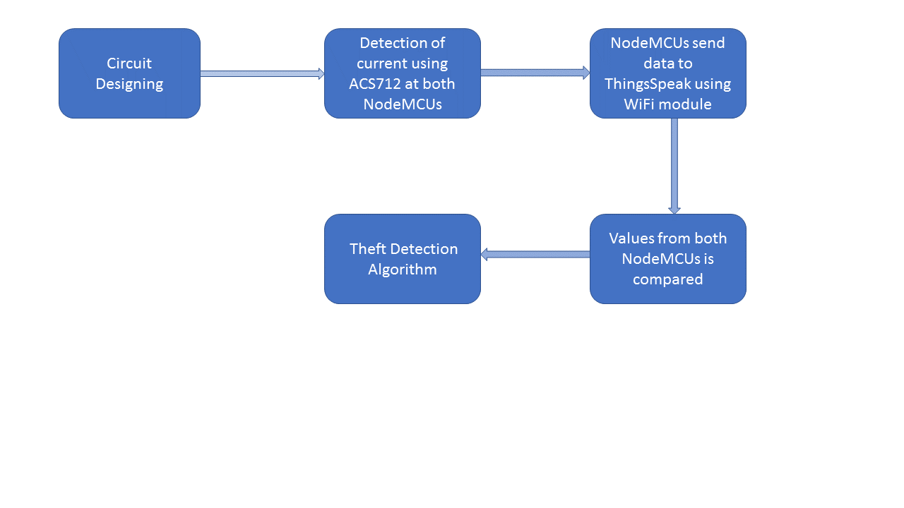

1. WORKING

* Initially, the circuit is to set up according to the requirement.
* The NodeMCUs are configured at the poles. The configuration of the NodeMCU involves uploading of the current sensing code for ACS712 and then uploading the current sensed to the thingspeak database.

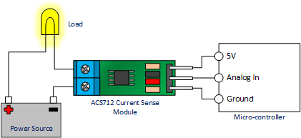

2. CONNNECTION OF ACS712 TO NODEMCU

* The thingspeak database has been setup with 2 field on a single channel. The two fields store the current values detected at the two poles.The data stored in the two fields are colllected by a python code and the theft detection algorithm is implemented on this data.
* The algorithm calculates the change in the current value between the poles and when this values exceeds a threshold ,considering the error in transmissions, the algorithm declares that a theft might have occured.
* The notification of the theft , if occured, is sent to the consumer and the electricity distributer.

**CHAPTER 4**

**TECHNOLOGY USED**

**4.1 NODEMCU(with ESP-8266):**

**NodeMCU** is an open source [IoT](https://en.wikipedia.org/wiki/Internet_of_Things)platform. It includes [firmware](https://en.wikipedia.org/wiki/Firmware) which runs on the [ESP8266](https://en.wikipedia.org/wiki/ESP8266) [Wi-Fi](https://en.wikipedia.org/wiki/Wi-Fi)[SoC](https://en.wikipedia.org/wiki/System_on_a_chip) from [Espressif Systems](https://en.wikipedia.org/w/index.php?title=Espressif_Systems&action=edit&redlink=1), and hardware which is based on the ESP-12 module. The term "NodeMCU" by default refers to the firmware rather than the development kits. The firmware uses the [Lua](https://en.wikipedia.org/wiki/Lua_(programming_language)) scripting language. It is based on the eLua project, and built on the Espressif Non-OS SDK for ESP8266. It uses many open source projects, such as lua-cjson, and spiffs.

**4.2 Thingspeak**:

According to its developers, "**ThingSpeak**is an [open source](https://en.wikipedia.org/wiki/Open_source) [Internet of Things](https://en.wikipedia.org/wiki/Internet_of_Things) (IoT) application and [API](https://en.wikipedia.org/wiki/API) to store and retrieve data from things using the [HTTP](https://en.wikipedia.org/wiki/HTTP) protocol over the Internet or via a Local Area Network. ThingSpeak enables the creation of sensor logging applications, location tracking applications, and a social network of things with status updates".

ThingSpeak was originally launched by ioBridge in 2010 as a service in support of IoT applications.

ThingSpeak has integrated support from the numerical computing software [MATLAB](https://en.wikipedia.org/wiki/MATLAB) from [MathWorks](https://en.wikipedia.org/wiki/MathWorks),[[4]](https://en.wikipedia.org/wiki/ThingSpeak#cite_note-4) allowing ThingSpeak users to analyze and visualize uploaded data using Matlab without requiring the purchase of a Matlab license from Mathworks.

ThingSpeak has a close relationship with [Mathworks](https://en.wikipedia.org/wiki/Mathworks), Inc. In fact, all of the ThingSpeak documentation is incorporated into the Mathworks' Matlab documentation [site](https://www.mathworks.com/help/thingspeak/) and even enabling registered Mathworks user accounts as valid login credentials on the ThingSpeak website.The terms of service and privacy policy of ThingSpeak.com are between the agreeing user and Mathworks, Inc.

ThingSpeak has been the subject of articles in specialized "[Maker](https://en.wikipedia.org/wiki/Maker_culture)" websites like [Instructables](https://en.wikipedia.org/wiki/Instructables), [Codeproject](https://en.wikipedia.org/wiki/The_Code_Project), and [Channel 9](https://en.wikipedia.org/wiki/Channel_9_(Microsoft)).

**4.3 Arduino IDE:**

The Arduino [integrated development environment](https://en.wikipedia.org/wiki/Integrated_development_environment) (IDE) is a [cross-platform](https://en.wikipedia.org/wiki/Cross-platform) application (for [Windows](https://en.wikipedia.org/wiki/Windows), [macOS](https://en.wikipedia.org/wiki/MacOS), [Linux](https://en.wikipedia.org/wiki/Linux)) that is written in the programming language [Java](https://en.wikipedia.org/wiki/Java_(programming_language)). It originated from the IDE for the languages [Processing](https://en.wikipedia.org/wiki/Processing_(programming_language)) and [Wiring](https://en.wikipedia.org/wiki/Wiring_(development_platform)). It includes a code editor with features such as text cutting and pasting, searching and replacing text, automatic indenting, [brace matching](https://en.wikipedia.org/wiki/Brace_matching), and [syntax highlighting](https://en.wikipedia.org/wiki/Syntax_highlighting), and provides simple *one-click* mechanisms to compile and upload programs to an Arduino board. It also contains a message area, a text console, a toolbar with buttons for common functions and a hierarchy of operation menus. The source code for the IDE is released under the [GNU General Public License](https://en.wikipedia.org/wiki/GNU_General_Public_License), version 2.

The Arduino IDE supports the languages [C](https://en.wikipedia.org/wiki/C_(programming_language)) and [C++](https://en.wikipedia.org/wiki/C%252B%252B) using special rules of code structuring. The Arduino IDE supplies a [software library](https://en.wikipedia.org/wiki/Software_library) from the [Wiring](https://en.wikipedia.org/wiki/Wiring_(development_platform)) project, which provides many common input and output procedures. User-written code only requires two basic functions, for starting the sketch and the main program loop, that are compiled and linked with a program stub *main()* into an executable [cyclic executive](https://en.wikipedia.org/wiki/Cyclic_executive) program with the [GNU toolchain](https://en.wikipedia.org/wiki/GNU_toolchain), also included with the IDE distribution. The Arduino IDE employs the program *avrdude* to convert the executable code into a text file in hexadecimal encoding that is loaded into the Arduino board by a loader program in the board's firmware.

### **Sketch**

A program written with the Arduino IDE is called a *sketch*.Sketches are saved on the development computer as text files with the file extension *.ino*. Arduino Software (IDE) pre-1.0 saved sketches with the extension *.pde*.

A minimal Arduino C/C++ program consist of only two functions:

* *setup()*: This function is called once when a sketch starts after power-up or reset. It is used to initialize variables, input and output pin modes, and other libraries needed in the sketch.
* *loop()*: After *setup()* has been called, function *loop()* is executed repeatedly in the main program. It controls the board until the board is powered off or is reset.

## 4.4 ACS-712:

The Allegro ACS712 provides economical and precise solutions for AC or DC current sensing in industrial, commercial, and communications systems. The device package allows for easy implementation by the customer. Typical applications include motor control, load detection and management, switched-mode power supplies, and overcurrent fault protection. The device consists of a precise, low-offset, linear Hall sensor circuit with a copper conduction path located near the surface of the die. Applied current flowing through this copper conduction path generates a magnetic field which is sensed by the integrated Hall IC and converted into a proportional voltage. Device accuracy is optimized through the close proximity of the magnetic signal to the Hall transducer. A precise, proportional voltage is provided by the low-offset, chopper-stabilized BiCMOS Hall IC, which is programmed for accuracy after packaging. The output of the device has a positive slope (>VIOUT(Q)) when an increasing current flows through the primary copper conduction path (from pins 1 and 2, to pins 3 and 4), which is the path used for current sensing. The internal resistance of this conductive path is 1.2 mΩ typical, providing low power loss. The thickness of the copper conductor allows survival of the device at up to 5× overcurrent conditions. The terminals of the conductive path are electrically isolated from the sensor leads (pins 5 through 8). This allows the ACS712 current sensor to be used in applications requiring electrical isolation without the use of opto-isolators or other costly isolation techniques.

**CHAPTER 5**

**RESULTS AND FUTURE SCOPE**

**5.1 Result:**

The given system results in detection of electricity theft while transmission of current from one distributor pole to receiver pole. The system can also be helpful in detection of non-technical losses because we monitor regular flow of current on both the sides. Also, Theft of service can be minimized which will be beneficial for economy as it is one of the biggest threat to most of the economies around the world. The system can also be used to detect if there is any fault in certain transmission line and thus can reduce losses as well as work force. Apart from all these applications the system provides financial securities to power utilizing companies by detecting thefts and so it can be extremely beneficial for company and can earn them huge profits.

**5.2 Scope and Future Work:**

This system can be used in grids to know the exact current passed to grid and the losses that occur while transfer of current. We can thus calculate the amount of energy lost while conversion of energy from one form to another.

Future design of the system can consist of a couple of current sensor inputs for each household. This can result in locating exact place where the theft has occurred. This system is very useful for areas like wildlife reserves, forests and all other remote areas where electricity theft is a major problem.

**CHAPTER 6**

**SUMMARY AND CONCLUSION**

**6.1 Summary:**

In this day to day life , illegal electricity theft has been a problem to almost most of the people and provider. This project helps in detecting the problem of illegal electricity thefts. Project uses hardware such as NodeMCU which provides an efficient way to track the power consumption using ACS-712 current sensor and store this data to cloud i.e thingspeak in our case. Thingspeak is a platform which provide an efficient way to show the power usage from both the side i.e provider and consumer side and works as a cloud storage for storing and accessing the data. Using this data, the detection algorithm on real time basis access this data and detects if there is illegal theft in between the circuit. On the basis of the detection algorithm if theft is detected, the notification of the alert is sent to the consumer as well as provider.

**6.2 Conclusion:**

We learnt a great deal through this project. We understood how the problems faced by the government and people in day-to-day life can be solved using technology. It broadened our understanding of technology and its scope and how seemingly tough problems can be solved using simple yet effective methods.

We learnt using various new technologies like we worked with a microcontroller NodeMCU which is far less known as compared to Arduino. NodeMCU served our purpose well also we found it to be great for IoT applications owing to an in-built Wi-Fi module. Also, this microcontroller has better performance as compared to Arduino and it is compatible with Arduino IDE which makes it easy to work with.

Electricity theft is a major issue faced by the government which leads to major losses for the government and in rural areas or areas with high forest cover the pin point detection of theft is very difficult leading to losses. There is a great need for a system that can determine the location of theft fairly accurately and notify the authorities in real-time.

By using the system that we have made, electricity theft can be detected and used for various scenarios like urban localities or for rural areas as well. The location of theft can be determined and in real time authorities can be notified of theft so that action can be taken against it. The implications of this system are great, if these losses are curbed then it’s a major saving for the government and this public money can be used for public good more effectively.

It is clear that this system can work well with the theft detection but it needs internet connectivity which is generally scarce in rural areas or areas with poor connectivity. There is a scope for improvement if any technology other than Internet is used for communication with the cloud and amongst the microcontrollers which should be cost effective and viable for rural areas.

**CHAPTER 7**

**REFERENCES**

1. Mutupe RM,Osuri SO, 2017. Electricity theft detection system with RF communication between distribution and customer usage. IEEE PES-IAS PowerAfrica.
2. Smith, T.B., 2004. Electricity theft: a comparative analysis. Energy Policy, 32(18), pp.2067-2076.